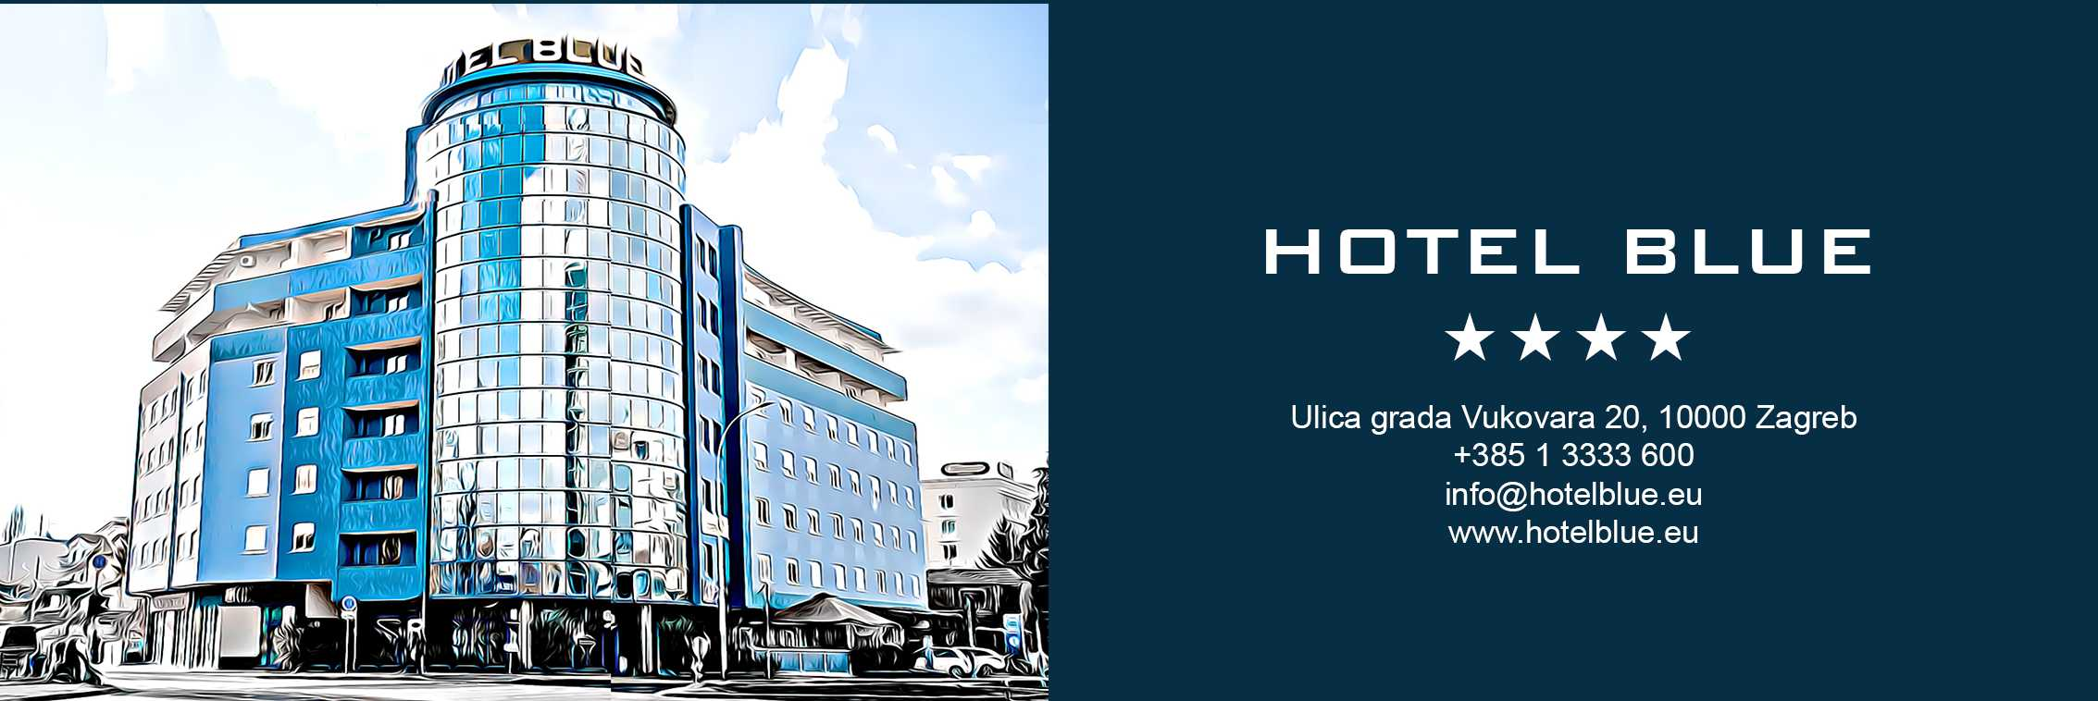

12.06.-14.06.2026. Zagreb Para Swimming Open

Single rooms 90 eur per night with breakfast included
Double rooms 100 eur per night with breakfast included
Triple rooms 110 eur per night with breakfast included

Surcharge for parking is 15 euros per day.

Participants are requested to reserve rooms no later than May 12, 2026.
Payment is required 10 days before arrival, after that free cancellation is not possible.

